**Animation State Machines**

Each entity that has the ability to change to several animations will be bound by the use of an animation state machine, this will allow us to control the entity’s visuals; locking their visual behaviour into the expected action they are currently performing.

**The Player:**

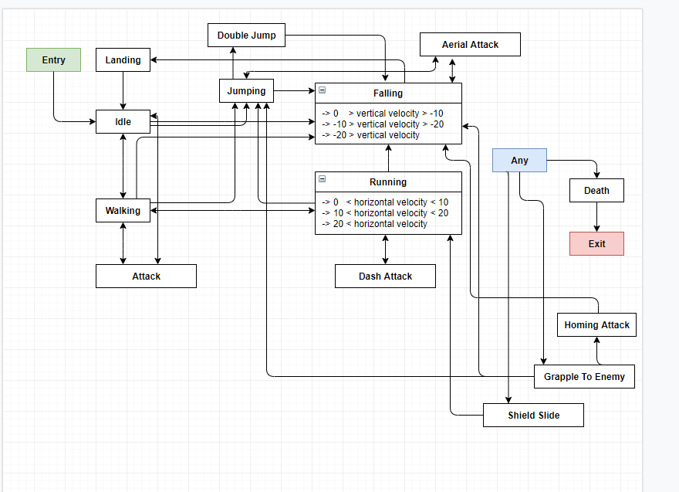

Figure 1 - Player Character animation state machine